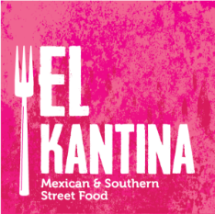
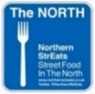

SUNDAY MARCH 10 MENU

FOOD SERVE TIMES 12-3 AND 4-6

MAIN MEALS £9, CHILDS PORTIONS £5 (CHILDREN UP TO 12 YEARS OLD ONLY
CHILD FRIENDLY VERSIONS OF THE BELOW ARE AVAILABLE!)

Large Fully Loaded Meat Feast Nachos

With chilli cheese sauce, coriander salsa, sweet chilli crema and Jalapenos with chargrilled Chorizo, Pork Carnitas, black beans and coriander

Greedy Gringo Box

A bit of everything! Black bean rice, House Slaw, Salsa, tortilla chips, Queso and Chipotle Crema and slow cooked Pork Carnitas

Mojito Lime Chicken Taco Basket
Rice, Mexican slaw, coriander, crema and jalapenos served in a Giant baked Taco basket
Warm Marinated Feta and Sweet Potato Giant Taco Basket (V)
Rice, Mexican slaw, s coriander, crema and jalapenos served in a Giant baked Taco basket
Large Fennel Roasted Vegetable Nachos (VG)

Chilli ‘cheese’ sauce, coriander salsa, sweet chilli vegan crema and Jalapenos with Fennel infused roasted veggies, black beans and coriander

Nibbly Bits on the side
Jalapenos
Pickles
Chilli Flakes
Hot sauces

